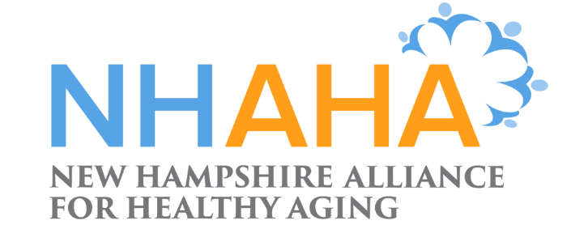

Creating a Collective Approach to Address an Aging NH

NH Alliance for Healthy Aging Quarterly (Virtual) Meeting
March 10, 2021
9:30 – 11:30 a.m.
Via ZOOM

Meeting highlights
Update on NH State Plan on Aging
Wendi Altman, Bureau Chief- Bureau of Elderly and Adult Services (BEAS), provided an update on the NH State Plan on Aging. The four-year plan is for the period of October 1, 2019 through September 30, 2023. Due to the pandemic occurring in early 2020, there have been needed adjustments and responses made to the work. Wendi reminded the audience that the plan is a true collaborative effort with agencies and organizations across the state. At a high level, the goals of the plan includes support for older people, person-centered thinking, and practices, advancing age friendly communities, ensuring the rights, safety, and dignity of older people, and preventing abuse and exploitation.
Wendi shared an informative slide deck (attached) with focus areas including workforce priorities and support for BEAS initiatives. The various forms of funding made available to NH from the COVID-19 stimulus were also aligned with the state plan.
From a BEAS perspective, Wendi shared some of the specific responses of the agency to the pandemic; these included informing agencies on how to respond within the guidelines established by local, state, and federal agencies, connecting funding sources with local needs, and creating flexibility around roles and doing business during the pandemic. BEAS also launched a good neighbor campaign with tips on how to protect older adults and report abuse.

Update on NH Commission on Aging (COA)
Rebecca Sky, COA Executive Director, provided an overview and update on the Commission’s activities and priorities. The Commission was formed in the fall of 2019 and Rebecca came aboard in January of 2020. In the attached presentation, Rebecca outlined her role and parameters. She shared that despite the limitations posed by the pandemic, COA undertook a successful strategic planning process from June – August last year and formerly released its strategic map in October of 2020. The pillars of the strategic planning (2020-2023) included: creating a dialogue, laying down the foundation, organizing for impact, and envisioning success. Part of the plan includes development of task forces: Aging in Communities of Choice, Age Friendly Task Force, COVID-19 Emerging Issues Task Force, and Operational Infrastructure Task Force.
The Commission also released its first annual report in November of 2020. It can be viewed at: https://nhcoa.nh.gov/
NHAHA Advocacy Update
Martha McLeod, Community Engagement Coordinator for NHAHA, provided an overview of key legislative issues as well as its story-telling project. Martha shared that as 2021 is a budget year, much of the conversation in Concord is revolving around that. Key bills and LSRs NHAHA is following include topic areas such as broad band access, advanced directives, telehealth, and transportation. Other key issues of focus are social isolation and seniors, COVID-19 equity task force, and vaccine roll out and process.
Martha also informed the group NHAHA’s story telling project. She explained that when developing policies and laws, legislators like hearing stories from constituents to put a face on the issue (in addition to understanding the numbers side). In particular, she and her team are inviting people to share experiences around caregiving and home care.
To learn more or be added to the weekly email list, please email Martha at: mmcleod@new-futures.org

2020 NHAHA Annual Survey
Alison Rataj, Project Director, UNH Institute for Health Policy and Practice, presented a summary of the annual survey. This is the fourth iteration of the survey and its results and feedback are used to influence and guide NHAHA’s work going forward. Alison was pleased to report that we had the most ever responses (59).
Key takeaways included: all NH counties represented (first time), 48 towns represented, 56% of responders are paid staff or providers, 19% indicated they were volunteers, and on average, survey takers have been part of NHAHA for three years. A majority of respondents felt NHAHA was making good progress on goals and over 60 percent felt NHAHA helped them expand their networks and knowledge of aging issues in NH. Those surveyed felt that among NHAHA’s accomplishments were changing the conversation on issues of aging, advocacy efforts, and providing education and tools.
For next steps, the results will be reviewed by the steering committee and advocacy work group who will make recommendations as to how to integrate results into work going forward.
Alison also drew the prize winner for the book raffle. Congratulations to Jennifer Ho’Sue, Cheryl Kimball and Ritamarie Moscola, MD!
Diversity, Equity, and Inclusion (DEI) Project Update
Talmira Hill, NHAHA consultant, provided an overview and update of numerous DEI efforts. The presentation (attached) included a reminder that the DEI lens and awareness should always remain at the center of NHAHA’s work. Highlights and initiatives over the past several months include: DEI workshops held in 2019 and 2020, the DEI climate survey completed last July, and the Photovoice project for empowering older adults of color and those whose first language is not English. Talmira examples of how the Transportation Workgroup has utilized the findings from the Photovoice project to strengthen its work and perspective. Key findings from the survey included that while NH is viewed as receptive to DEI issues, there could be a more intentional effort to engage people of color, people whose first language is not English, those with sensory and cognitive issues and people with disabilities.
To learn about NHAHA’s DEI work, please contact: talmira@thehillgroup.org or Jennifer.rabalais@unh.edu
Networking period
Following the formal presentations, attendees participated in virtual breakout rooms to network and discuss areas of common interest.

A full recording of the meeting can be viewed here

2021 Meeting Schedule
June 10, 2021
September 8, 2021
December 9, 2021

